系统截图：http://10.11.17.253:98/ 账号密码 admin 111111

储能电站健康管理系统
易事特储能电站健康管理系统，构建电站-设备-器件多层健康指标，从电池一致性、异常工况、运行效率等多维度进行数据分析，具备安全预警与智能诊断能力，实现运维全流程数字化闭环，全面提升储能电站安全性、运行效率与设备寿命。

East Energy Storage Health Management System
Multi-layer health monitoring for stations, equipment and components. Data-driven analysis on battery consistency, operating status and efficiency enables safety early warning and intelligent diagnosis, achieving full digital O&M closed-loop to enhance safety, efficiency and lifespan of energy storage systems.

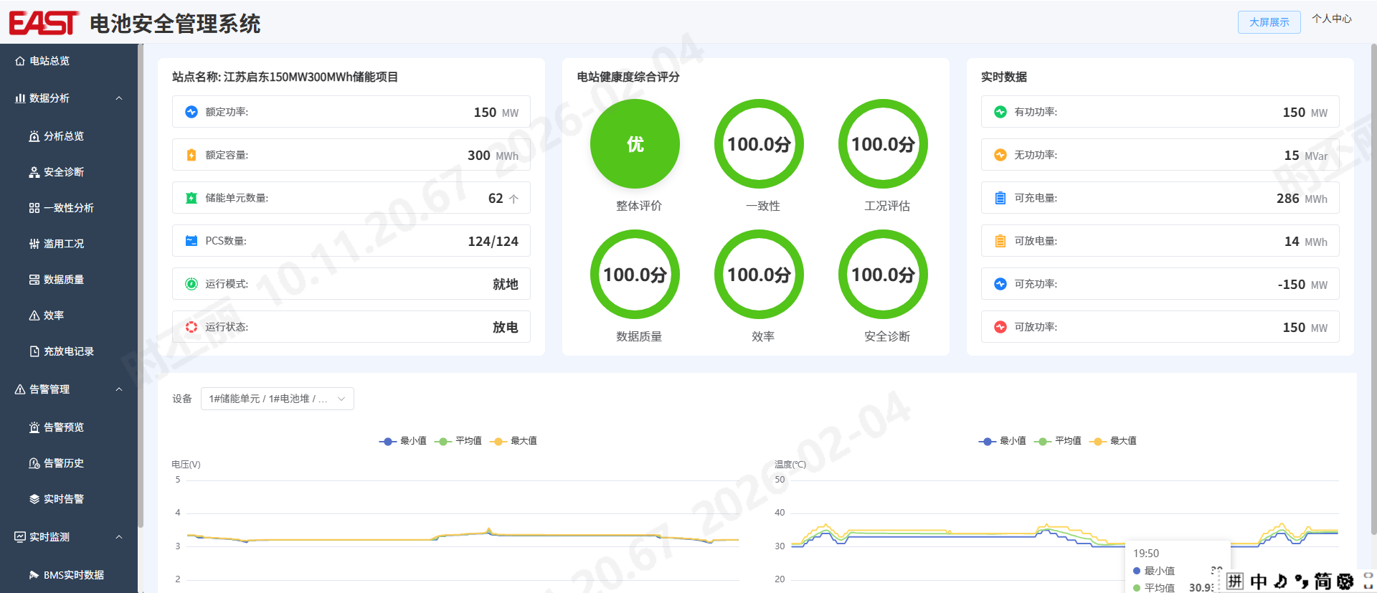
平台特点：
- 全面安全防护
- 多层次纵深防护体系，场站-设备-器件级多层级评估电站运行情况
- 广泛覆盖，电池、PCS、箱变、动环、电气连接件等全场站设备监控管理
- 多维度诊断：一致性、滥用工况、异常衰竭、电气连接、数据质量、效率、安全诊断等多维度全面诊断
- 主动运维，降低非停损失
- “实时告警→安全预警→定期诊断”的主动防御体系，防患于未然
- 智能预警，提前30天识别容量异常，7天识别安全隐患，精准维护，减少更换与停机损失
- 全生命周期价值管理
- 智能识别性能短板，有效提升系统整体可用容量与运行效率，守护资产长期价值
- 持续的性能评估，形成“监控-分析-运维-优化”的管理闭环，支撑运营决策

Platform Features
Comprehensive Safety Protection
- Multi-layered defense covering station, equipment and component-level assessment
- Full-site monitoring for batteries, PCS, box-type transformers, BPS, electrical connections and more
- Multi-dimensional diagnostics: consistency, abusive conditions, abnormal degradation, electrical connections, data quality, efficiency and safety

Proactive O&M, Reduced Outage Losses
- Proactive defense: real-time alerts → safety pre-warning → periodic diagnosis
- Intelligent early warning: 30-day capacity anomaly detection, 7-day safety risk identification for precise maintenance

Full-Lifecycle Value Management
- Intelligent performance optimization boosts usable capacity and efficiency, preserving long-term asset value
- Closed-loop management: monitoring → analysis → O&M → optimization, supporting data-driven operational decisions
技术参数Technical Specifications
产品型号Product Models | EAPHMS-DM266
系统System
核心功能Primary Functions | Multi-dimensional consistency analysis of voltage, temperature, SOC, combined with safety diagnosis and anomaly warning, enables full-equipment monitoring from cells to PCS, power environment and box-type transformers. Data-driven assessment covers station-level health, energy efficiency and reliability.
采集参数Collected Parameters
采集支持设备  Supported Devices | 箱变、变流器、电池堆、电池簇、电芯  Box-type transformer,PCS,PACK,Cell
采集间隔  Acquisition Interval | 默认15s（可配置）  Default: 15s (configurable)
存储容量指标Storage Capacity Metrics
历史数据存储时间  Historical Data Retention Period | ≥2年  ≥2 years
磁盘容量告警  Disk Capacity Alarm | 80%（当存储容量余额低于系统运行要求容量的80%时发出告警信息）  80%(Alarm triggered when remaining storage capacity falls below 80% of the system’s required operating capacity)
实时数据库容量  Real-time Database Capacity | 模拟量大于或等于150万点  状态量大于或等于80万点  Analog values ≥ 1.5 million points  Status values ≥ 800,000 points
历史数据库存储容量  Historical Database Storage Capacity | 历史曲线采样间隔为1～30min（可调）  支持秒级存储  日报，月报，年报存储时间大于或等于2年  历史趋势曲线大于或等于300条  • Historical curve sampling interval: 1–30 min (adjustable)  • Supports second-level data storage  • Daily, monthly & annual reports stored for ≥ 2 years  • Historical trend curves: ≥ 300 items
通讯Communication
通讯介质Communication Media | 光纤/以太网  Fiber/Ethernet
组网形式Network Topology | 总线型/星型/环网  Bus/Star/Ring topology
通讯规约Communication Media | IEC 60870-5-104、自定义规约  IEC 60870-5-104, Custom Protocol
屏柜Cabinet
尺寸（宽*高*深）  Dimensions (W×H×D) | 800 mm * 2260 mm * 1000 mm

